GNU Octave, version 3.8.2
Copyright (C) 2014 John W. Eaton and others.
This is free software; see the source code for copying conditions.
There is ABSOLUTELY NO WARRANTY; not even for MERCHANTABILITY or
FITNESS FOR A PARTICULAR PURPOSE. For details, type 'warranty'.

Octave was configured for "x86_64-pc-linux-gnu".

Additional information about Octave is available at http://www.octave.org.

Please contribute if you find this software useful.
For more information, visit http://www.octave.org/get-involved.html

Read http://www.octave.org/bugs.html to learn how to submit bug reports.
For information about changes from previous versions, type 'news'.

a = 1.000000
l = 1.000000
T = 0.050000

ε =
1.0000e-10

Начальное возмущение =
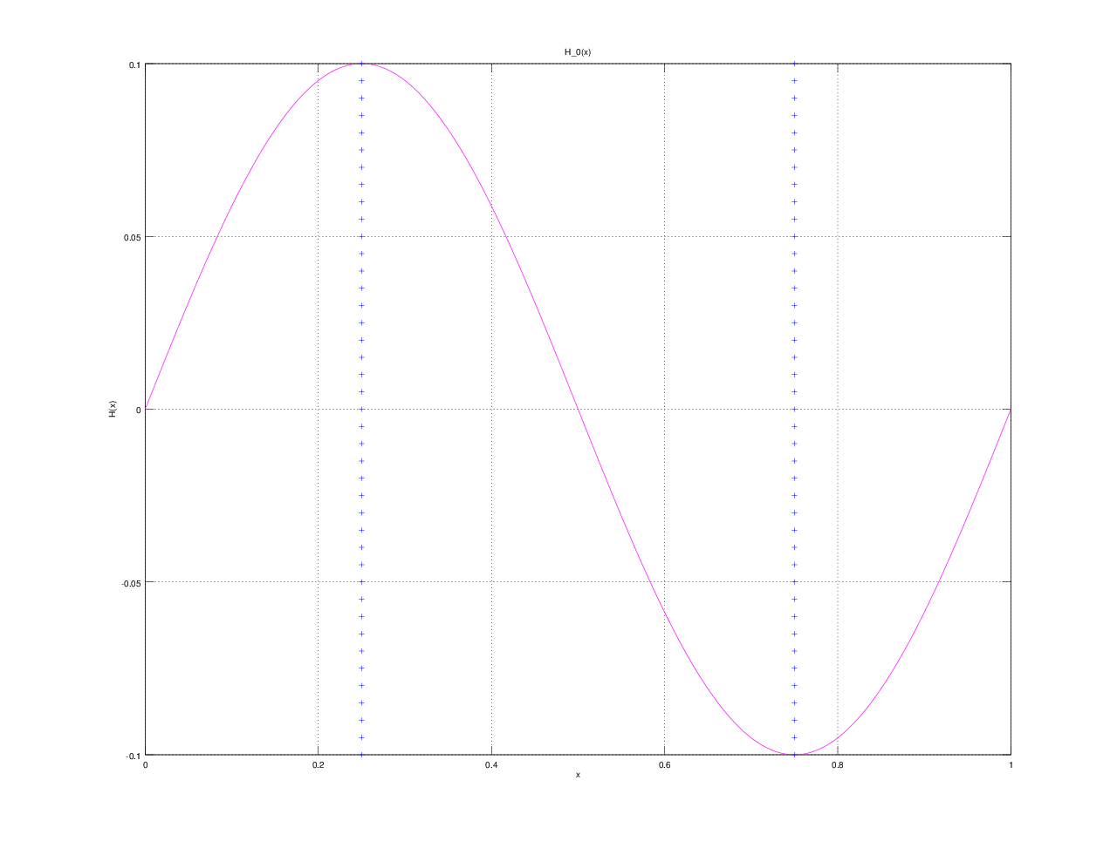
0.1 * sin(2 * pi * x)

